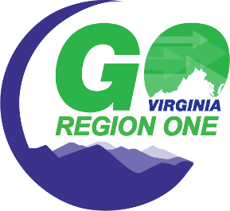
GO Virginia Region One Quarterly Progress Report Template
Subgrantee: Appalachian Voices
Project Title: Solar Playbook
Project PI: Adam Wells

Project Milestones & Progress Reporting (Responses should be limited to under 2,000 characters)
- Please provide a description of project work completed or in progress this quarter. Please list activities as they relate to the milestones outlined in “Project Addendum C”.

- Please describe any outcomes that have been achieved. Please refer to the products listed in “Project Addendum C”.

- Please describe any barriers to the project at this time.

- Media articles attachment

Comments & Notes

